

Name: Husam Ali Abdall Nour
PRN: 25070122086
Branch: CSE (2025-29) Semester: 3

Subject: Programming with Java
ASSIGNMENT No.: 6
TITLE: : Write a Java program to demonstrate the use of an inner class, an anonymous class.

Problem Statement:

Write a Java program to demonstrate the use of an inner class, an anonymous class.

Learning Objectives:

To implement inner classes and anonymous classes for improving encapsulation and event handling in Java.

Theory:

An inner class is a class defined inside another class and has access to all members of the enclosing class, including private members. Inner classes help improve code organization and logical grouping of related classes. Anonymous classes are unnamed inner classes that are instantiated only once and are mainly used for implementing interfaces or abstract classes. They simplify code by eliminating the need for separate class definitions. These concepts are widely used in Java GUI programming and event handling.

Outcomes:
The inner class was successfully used to access private members of the outer class, demonstrating tight encapsulation. The anonymous class was used to provide a one-time implementation of the Greet interface without creating a separate named class. This showed how inner and anonymous classes reduce code overhead for tasks that don't need reusable class definitions.
class Outer { private String message = "Hello from Outer class";
class Inner { void display() {
System.out.println("Inner class accessing: " + message);
}
}
} interface Greet { void sayHello();
} public class JAVA_EXP_6 { public static void main(String[] args) {
Outer outer = new Outer();
Outer.Inner inner = outer.new Inner(); inner.display();

Greet g = new Greet() { public void sayHello() {
System.out.println("Hello from Anonymous class");
}
};
g.sayHello();
}
}

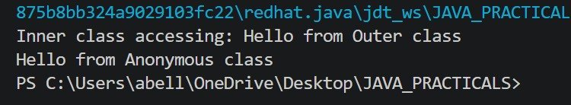

Conclusion:
Inner and anonymous classes enhance Java's object-oriented capabilities by enabling tighter encapsulation and concise, one-time implementations.

Exercise:

1.Create a Vehicle program where an inner class displays vehicle details and anonymous class
performs an action.

class Vehicle{ private String name; private String type; private int speed;

Vehicle(String n, String t, int s){ this.name = n; this.type = t; this.speed = s;
} class VehicleDetails{ void show(){
System.out.println("Vehicle Name: " + name);
System.out.println("Type: " + type);
System.out.println("Top Speed: " + speed + " km/h");
}
}
} interface Action{
void performAction();
} public class JAVA_EXP_6{
public static void main(String[] args) {
Vehicle v = new Vehicle("Ferrari 488", "Sports Car",330);
Vehicle.VehicleDetails details = v.new VehicleDetails(); details.show();

Action start = new Action(){ public void performAction(){
System.out.println("Vehicle is starting the engine and moving forward."); } };
start.performAction();

}
}

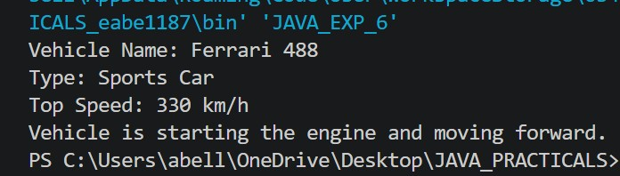

2. Develop a Food Delivery Application where an inner class handles order details and anonymous classes handle delivery status updates.

class FoodOrder { private String customerName; private String foodItem; private double price;

FoodOrder(String customerName, String foodItem, double price) { this.customerName = customerName; this.foodItem = foodItem; this.price = price;
} class OrderDetails { void showOrder() {
System.out.println("Customer: " + customerName);
System.out.println("Food Item: " + foodItem);
System.out.println("Price: Rs. " + price);
}
}
}
interface DeliveryStatus { void updateStatus();
} public class JAVA_EXP_6{
public static void main(String[] args) {
FoodOrder order = new FoodOrder("Husam", "Kadai Paneer", 250);
FoodOrder.OrderDetails orderDetails = order.new OrderDetails(); orderDetails.showOrder();

DeliveryStatus preparing = new DeliveryStatus() { public void updateStatus(){
System.out.println("Status: Order is being prepared");
}
};
preparing.updateStatus();

DeliveryStatus outForDelivery = new DeliveryStatus() { public void updateStatus(){
System.out.println("Status: Order is out for delivery");
} }; outForDelivery.updateStatus();

DeliveryStatus delivered = new DeliveryStatus() { public void updateStatus(){
System.out.println("Status: Order has been delivered");
} }; delivered.updateStatus();
}

}

